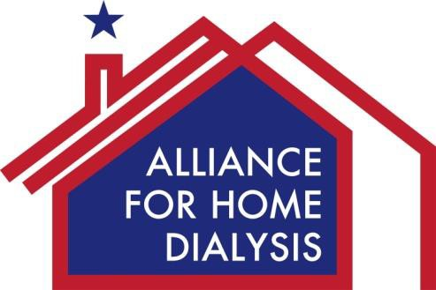 KIDNEY DISEASE EDUCATION

What is Kidney Disease Education (KDE)?
Medicare pays for health care providers to educate patients on how to manage their kidney disease, and what treatment options they have if the disease progresses. KDE can help patients make more informed choices, receive a better quality of life, and handle the physical, emotional and financial changes ahead. KDE can also help more patients choose home dialysis, if appropriate for them.

Unfortunately, KDE is extremely underutilized. The Government Accountability Office (GAO) found that less than 2% of eligible patients use KDE benefits.

Who is eligible to receive KDE?
Patients with Stage 4 chronic kidney disease (CKD) are eligible to receive KDE. CKD has 5 stages -- Stage 5 patients are in kidney failure, and patients are diagnosed with end-stage renal disease. Stage 4 CKD patients are at risk of kidney failure but do not yet require dialysis. Currently, Medicare covers up to 6 one hour KDE sessions.

Who provides KDE?
An individual’s physician must “prescribe” KDE. Physicians, nurse practitioners, physician assistants or clinical nurse specialists can provide the service. KDE can take place at a rural hospital, critical access hospital, skilled nursing facility, outpatient rehab facility, home health agency, or hospice.

How can we increase access to KDE?
To increase access, we recommend:
- Authorize reimbursement for KDE provided at dialysis facilities
- Allow physician assistants, nurse practitioners, clinical nurse specialists, to “refer to” (prescribe) KDE services
- Permit KDE for Stage V CKD patients
- Include masters level social workers and home dialysis nurses with five or more years of experience in the definition of a person qualified to provide KDE
- Include kidney disease education services as a mandatory service for Medicaid beneficiaries with CKD/ESRD.

